Feasibility Report

By Group 20 Of Sys Analysis Desn Class

Group 20

Abid Rana

November 20, 2021

Index 1

1.1 Purpose

1.2 Scope

1.3 System Overview

2. financial breakdown

3. Organizational breakdown

4.Technical view

5. Conclusion

1.1 Purpose

The purpose of the system we are making is to store customers data(ex; name, address, health card number), also add on to it(ex; store additional information like medical history, and lab data). It will also have the ability to cross reference a customer’s health card in real time. The system well as have the ability for health staff to send billable hours to the government for their services.To summarize The purpose of the software would be this, to handle customer, date, interaction with both customers, and provincial governments, and lastly a method for healthcare works to bill the government for the work they’ve completed.

| Title | ABC SPARK | | |
| --- | --- | --- | --- |
| Project Manager | Nate | DATE | NOV 22,2021 |
| Project Justification | With The ABC Spark tool creation, user of the application will have a means to input data into a database for storage and safe keeping, and will also have tools to help with interactions between both customers, government body. | | |
| Project Scope | An all in one database with an user interface that lets the user store and update customer data on the database, plus a portal to send any forms to the right governing body. | | |
| Project Objective | To create a tool that enables user to input and update data given to them by a customer, and organize and send data to the government(minister of health). | | |
| High lvl requirements | -User access for the tool for the employees of ABC Clinic  -Admin access to tool  -Generate reports on a weekly basses  -Send bill for work done to the government | | |
| In Scope | -Access tool by Desktop  -Admin control/access promotion  -Copy and store previous Reports | | |
| Out of Scope | -Make more title for employee’s  -Track total hours worked and have it displayed in the employee user account | | |
| Cost | 1,000,000 Cap | | |

Scope 1.2

Project Scope

System Overview 1.3

permanent patients, can either book, cancel or reschedule an appointment either online or by calling the front desk. Once booked an appointment can only be cancelled or rescheduled until 24 hours before the scheduled time. No shows or missed appointments are charged 30$ Patients do not have to pay for medical services in Canada however they are certain items that are not covered by the government and the patients will be required to pay for these services such as medical/sick notes, travel vaccinations etc. We will accept payments in cash or via a major credit card.

Patients may also come as a walk-in patient during the business hours and are put in the queue for the first available physician at that time (They cannot book a walk- in appointment). The system should keep a track of patients’ appointment and change the status accordingly: booked, cancelled, arrived, Checked IN, Checked OUT, LWT(left without treatment), No show etc.

Walk in patients are checked in, placed in the queue and are seen by the next available doctor. There are two exceptions to this process; a patient may request to be seen by a particular doctor and a patient may jump the wait line in case of an urgent need i.e. the triage process (i.e. chest pain, wound treatment etc.). The default time slot for patient appointment with doctor is 15 minutes but patients with special circumstances can be scheduled for double time (30 minutes).

The system should store patients’ basic information including her name, address, contact, health card, and his or her previous history of visits, treatment, medications, and lab results. Upon arrival (both scheduled and walk in) the receptionist would verify each patient’s health card in real time (linked directly with ministry’s system), address and contact details and then the secretary marks “checked in” status. At the end of the appointment, the secretary marks a “check out” status.

The nurse will note down, temperature, height, weight blood pressure and brief history of problems/symptoms and notes it down in the system. The patient is then seen by a doctor who would enter patient’s complaints/symptoms, diagnosis and medications prescribed.

The doctor should be able to do the following three tasks either by generating a print out from the system (and hand it to the patient) or send directly to the external party electronically (if the third party offers an electronic interface).

* Prescriptions (print out given to the patient or sent to the pharmacy electronically)
* Lab Requisitions (print out given to the patient or sent to the Laboratory electronically: and receiving the test results back electronically as well)
* Specialist Referrals (print out given to the patient or sent to Specialists doctors’ offices electronically: and receiving the specialists notes/letters back electronically as well)

The system should be able to store scanned copies of paper documents in some situations (for instance: in case of receiving paper based lab results/specialist letters.

In case of any abnormal lab test results, patient should be recalled back to the clinic immediately to be seen by a doctor and discuss the results. The system should keep a track of all the calls made or messages sent to the patient by the clinic.

The physicians are paid directly by the government for the services rendered to the patients. The system should provide the capability for the doctors to bill the government for their services and see their payments.

There are however some patients who do not have government health coverage and they may pay cash, or may have coverage by an insurance company and the system should provide the Accounts Receivable and payable functionality for these and other cash payments (non-covered services mentioned before).

The system should also provide reports about patients, visits, financial accounts, usage statistics etc.

2. financial breakdown

Anticipation

“We are anticipating to serve to approximately 1500-2000 patients per week on the average. We will initially have ten physicians (doctors), six nurses and eight receptionists and two Assistant managers running the day to day affairs of the clinic. Our clinic will be open 9a. to 7p.m Monday to Saturday. “ — Owner of ABC Clinic

The Economic Feasibility Analysis was made with the idea that ABC Cl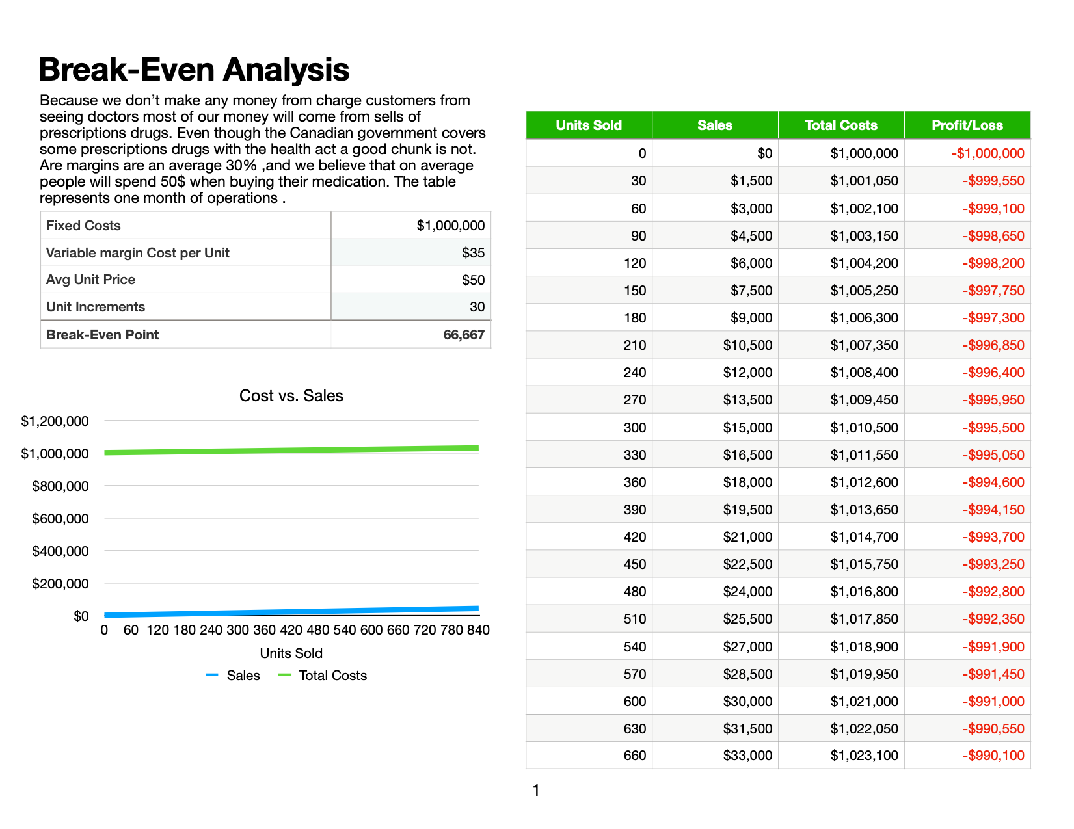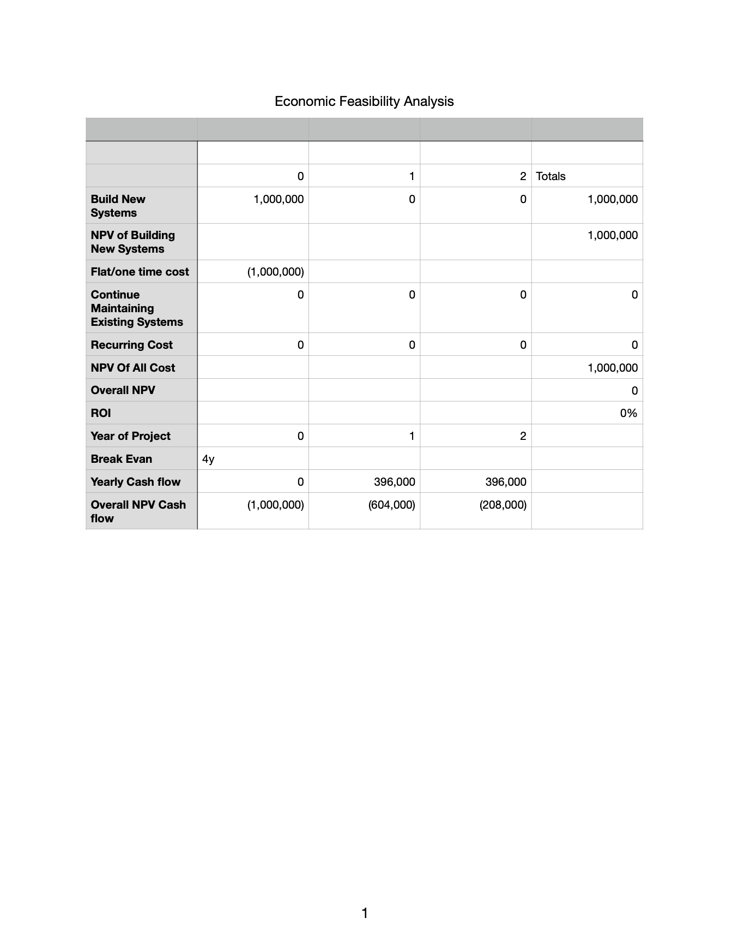inic Paid 1,000,000 For the creation of the software.

Any additional fee’s will have to be discussed at a later date.

3. Organizational breakdown of group 20

1. President (Michael Noseworthy)
2. Executive Vice President (Jorrel Tigbayen)
3. Senior Director(Nahom Tekle, David Fortich)
4. Manager (Dennis Varghese)
5. Middle Manager of people(Mustafa Bandukda)
6. Employees(Zake Fisher, Tom Cake),
7. contract employees(Bill John,mark H),
8. part-time employees(Cait Duck, Luke Ham, Ryan b, Tom C)

4.Technical view

* **Market Statistics:** Toronto Population is more recently estimated for 2019 at over 3,060,000 people. This is predicted is to increase to 3,109,676 in the following year (2020). Is estimated to grow to almost 3,500,000 by 2030 which is an increase of 13% from 2020.2016 marked the first time that there were more people aged 65 years and over, than 14 and under. The share of seniors aged 65 years and over increased over the ten years from 2006 (14%) to 2016 (16%). By 2030, this figure is projected to increase and represent about 19% of the population, or more than 678,000 individuals. Life expectancy is 86.6 years for females and 82.0 years for males, figures that are higher than those for Ontario (Ontario females: 84.2 years, Ontario males: 80.3 years). In summery the population of Toronto is increasing, and people theirs more old people than teens. Older people are more likely to visit a walk-in clinic than a teen or young adult, so with the current shift in our population from younger people to old we stand to gain more customers go forward. Data set collected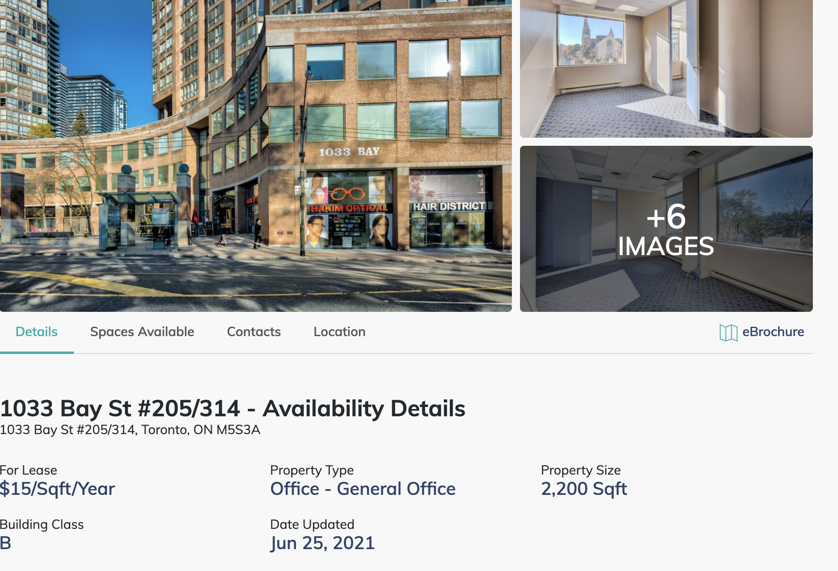 from(<https://www.toronto.ca/wp-content/uploads/2019/11/99b4-TOHealthCheck_2019Chapter1.pdf>)
* **Potential Locations:**

1033 bay St #205/314

Currently in terms of leasing cost and location 1033 bay st is by far the closest thing to an agreeable contract. The good thing about this location is that it’s not directly beside another clinic, and that the

location is surrounded by large high population apartments.

* **Competition:**  City Map

With around 240 different medical practice/discipline in Toronto the markets is some what crowded But we believe that ABC clinic with the help of our into tools can break into this market, as the ABC Clinic Motto go’s “we deliver the best possible healthcare to our patients.” Most of the companions our Toronto lack a strong brand, and have relatively bad customers support in comparison to large hospitals.

* **Industry Analysis:** Can’t be done there is no publicly available data on Canadian walk-in clinic !
* **Current Economic Environment:** We are still in a pandemic more clinic will help reduce stress on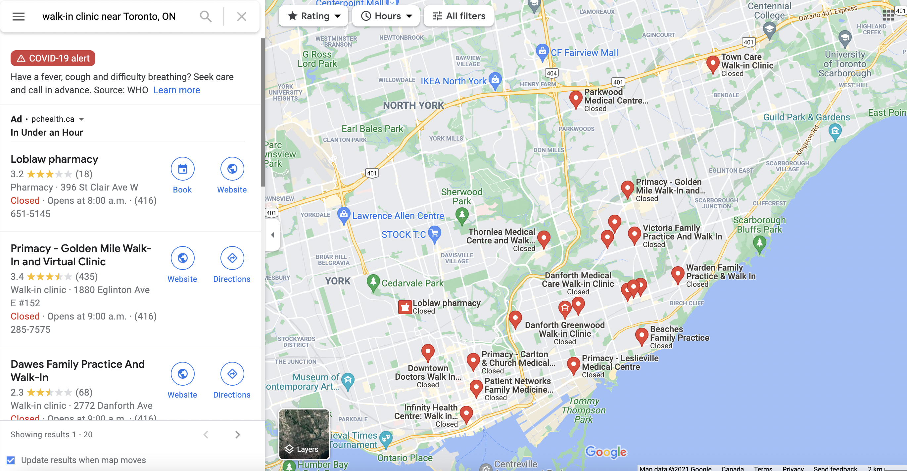 general admission hospitals. Even though it looks like covid-19 is ended virus is most commonly believed to not be kill able, human might have to co-exist with it going into the future meaning that even if most of the population of Toronto is vaccined that doesn’t meaning that everyone else around the world is and once people start travelling again new variants my pop up, so the demand for health care workers are pretty high. (authors note as of November 26,2021 it was just announce on CNN that new variant was found called Omicron a highly mutated form of covid-19)

5. Conclusion

We of group 20 be that the creation a new walk-in clinic in Toronto back by our Spark Tools is a recipe for success. The first two years might look pretty rocky, but if ABC Clinic serves 1500-2000 people a week for the next three years after the creation of our tool we believe they have a reasonably bright future ahead of them .